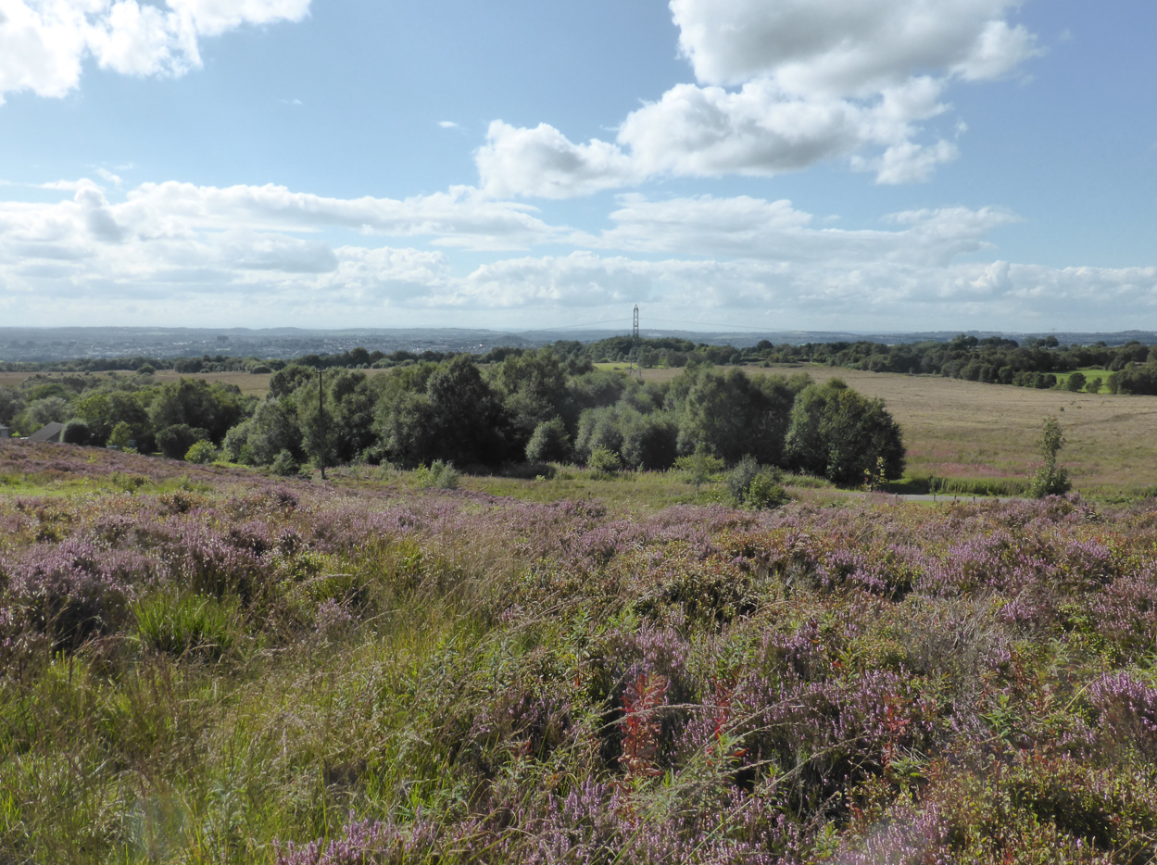
Wetley Moor Common © Mark Preece
Job Title Senior Reserves Officer – Staffordshire Moorlands
Be part of a Wilder Future
Closing date: Friday 20th November 2026
Interviews: Monday 7th December 2026
Please submit your completed application to jobs@staffs-wildlife.org.uk before the closing date

Join Our Movement
We are the county’s leading conservation charity, committed to protecting wildlife and inspiring a lifelong love of nature. Our climate is in crisis and nature needs our help, but together we can make a difference.
Our 50-year vision is for a thriving county with wildlife at its heart, which everyone enjoys, values and wants to play their part in protecting and improving.
Our mission is to ensure that:
We protect and enhance the wildlife and wild places of Staffordshire and promote understanding, enjoyment and involvement in the natural world.
Working for Staffordshire Wildlife Trust, in any role, means you are part of our ambition to halt and reverse natures decline in Staffordshire and across the UK, and to get more people to take meaningful action for wildlife. Whether you work in IT, in our cafes, or out on our nature reserves you will be working with colleagues towards the common purpose of a county richer in wildlife.

CHRISTINE HARDING SWT

Working for us
At Staffordshire Wildlife Trust we don’t just offer jobs – we offer careers. For our people, being part of the effort to address the climate and nature crisis makes working for us truly meaningful and rewarding.
As well as investing in our mission, we invest in our people and culture. We’re committed to creating an engaging, supportive and inclusive workplace for all and providing opportunities for development, training and growth. We also provide a range of benefits such as flexible working, an employee assistance programme and a wellbeing allowance.
Your journey in the Trust starts with your induction. Whatever role you're here to do, we'll explain what to expect, show you where to go, and make sure you understand your new environment before you get going.
You’ll get chance to see what others in your teams, and across the Trust are doing through job shadowing and team working. We have 45 other Wildlife Trusts, working passionately just like us, whose knowledge and experience you can also draw from.
Learning and development
One size doesn’t fit all, we will work with you to identify where you and the organisation want to grow and develop and put together a personal plan that works for you, whether that’s on-the-job training, flexible e-learning, or one-to-one support.
If we need you to hold a qualification for your role, from either a legal or professional point of view, we will cover the cost of your membership fee where needed as part of your continuous professional development.
We believe work-life balance is important. We work 35 hours a week, and we believe a good work life balance makes for happier, healthier employees. We support flexible working wherever possible, and we are currently trialling a hybrid working model.
We have a range of benefits that support you when working for us:
- 10% Non-contributory Pension
- Healthcare Plan
- Employee Assistance Programmes
- Life Assurance (4 x salary)
- Salary Sacrifice schemes for cycle to work and Electric vehicles (dependant on salary)
- 25 Days basic holiday allowance (rising to 30 days after 10 years’ service), plus bank holidays, and extra Christmas leave (pro rata)
- Option to purchase additional holidays subject to meeting criteria
- 15% discount in our cafes
- PPE and uniform provided as required.
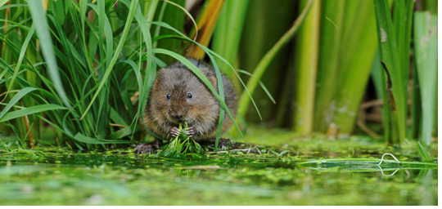

What we stand for
TERRY WHITTAKER 2020/VISION
We are:
Resourceful: Making best use of what we have, and always alive to opportunities to do things better and more efficiently
Passionate: Making the case for valuing and protecting wildlife
Pioneering: Using new and innovative ways to achieve our vision helping us led by example
Evidence Based: Making our case on scientific-face and interpretation
Welcoming: Giving our members, our supporters, and the wider public the best service possible
Professional: Striving to be the best we can be in all that we do, seeking continuous improvement and benchmarking our performance
Collaborative: Working in partnerships between staff, volunteers, members, communities, landowners, businesses and many others to achieve our vision
Safeguarding
Staffordshire Wildlife Trust is committed to keeping children and young people safe, you can see our policy here: https://www.staffs-wildlife.org.uk/our-policies
Safeguarding and protecting our visitors, customers, members, staff and volunteers is the responsibility of every trustee, employee, and volunteer at Staffordshire Wildlife Trust.

Our commitment to safeguarding starts at the very beginning. All recruiting managers complete Safer Recruitment training to enable them to follow best practice when recruiting.

On joining all staff are required to complete safeguarding training for children, young people and adults at risk.

Some roles require a successful DBS check before they can carry out their roles.
Our safeguarding team is committed to ensuring that our safeguarding policies and procedures are adhered to.

EDI – we’re wild about inclusion!
We aim to put equality, diversity and inclusion at the heart of Staffordshire Wildlife Trust to ensure that everyone has the opportunity to experience the joy of wildlife in their daily lives.

We’re Wild About Inclusion! To us, this means inspiring, empowering, and engaging people from all backgrounds, cultures, identities, and abilities, to change the natural world for the better. It means creating workspaces where difference is celebrated, everyone can be themselves and flourish, just like nature.

We aim to better understand and address the inequalities experienced by many communities in accessing and connecting with nature. This includes recognising that the conservation sector is one of the least diverse professions in the UK and that access to careers and educational opportunities needs to be significantly improved. We believe being Wild About Inclusion is critical to the future of the Trust, and the health and wellbeing of our communities.

The basics
Job Title: Senior Reserves Officer, Staffordshire Moorlands Estate
Contract Type: Permanent
Hours: 35 hours/week
Pay £26,250
Work Location: Marsh Farm, Meerbrook. 4 miles north of Leek.

Who we’re looking for
The senior officer responsible for our Staffordshire Moorlands estate is a key role at SWT, providing leadership within our Reserves team, working alongside a team of expert delivery staff and volunteers, whilst developing future opportunities with colleagues and external partners to ensure that SWT’s work is continuously increasing nature’s diversity and abundance.

Based mainly at our regional office 4 miles from Leek, and with direct responsibility for our 11 sites in the Staffordshire Moorlands which are leased from Staffordshire Moorlands District Council (SMDC), the senior officer will work with the SMDC Assistant and local volunteer groups to manage these nature reserves. The post holder will also work with our wider nature reserves team across the county.

As a senior member of the Reserves team and Conservation departments within SWT, the Staffs Moorlands Reserves Officer will play an important part in the department. With a mixture of practical delivery, volunteer leadership and project management, the successful candidate will have a positive attitude, being good-spirited and committed, being able to work well individually, but equally well as part of a small team. With knowledge and experience of working within the environmental sector the successful candidate will be motivated by having the opportunity to demonstrate that nature’s recovery is possible and driven to evidence to communicate this to a wide range of stakeholders.

With their endless passion for our work, the successful candidate will help with the protection and care of habitats, wildlife, property and machinery, and their passion will inspire others to love the beautiful species and places as much as we do.

What you will deliver
- Carry out and maintain overall responsibility for the physical management of the Trust’s SMDC estate in the north of the county on a day-to-day basis through co-ordinating volunteer work parties and overseeing the delivery of a range of contracts.

- Responsible for following and reviewing the individual sites’ management plans.

- Line management responsibilities for the SMDC Assistant Warden

- Gain a clear understanding of the agri-environment and grant schemes that the Trust holds on the SMDC sites and ensure the site management activities are fully compliant.

- Seek other funding opportunities to develop projects and deliver capital works identified in each management plan.

- Be responsible for health and safety and implementing any relevant systems (e.g. risk assessments, tree safety) and demonstrating adequate monitoring of relevant systems.
- Ensure a close link is maintained with the local community and key user groups (Friends of groups, dog walkers, ramblers, Parish Councils etc.) and regularly interact with visitors to promote the work of the Trust and the benefits of membership where appropriate.

- Ensure a high-quality visitor experience is maintained through regular maintenance, particularly with reference to footpaths, litter picking, removal / replacement of outdated signage etc

- Be responsible for preparing and managing annual budgets for the SMDC Reserves

- Be available for media work including TV and radio interviews to promote our work.

- All staff should recognise the contribution that membership makes towards the running of the organisation. The postholder is therefore expected to understand the need for high standards of service to existing members and recognise their role in contributing towards ongoing membership recruitment.

- In order for the organisation to work effectively you may be required to assist with other areas of work and therefore you should be prepared to undertake other duties, appropriate to the post, as delegated by your line manager.

- All staff are required to abide by organisational policies and procedures.
- Regular weekend work and occasional evening work will be required and therefore a flexible approach is essential.

What we’re looking for – Qualities and Requirements
Personal Qualities
Passionate and energetic | You will believe in our core purpose and be passionate about tackling the nature and climate crisis and understanding the part we play.
Team focused and supportive | You will encourage, excite and support your team to achieve their best potential thereby resulting in continuous improvement.
Ambitious and achieving | You will provide direction for your team and ensure your work delivers against our core strategic goals. You will energise and motivate your colleagues.
Resource efficient | You will use resources wisely ensuring maximum benefits and minimal cost.
Professionalism | Always professional, on-message and on-brand – you will represent the Wildlife Trust and its values and mission at all times.
Determination and resilience | You will have a can-do attitude and will take setbacks and feedback constructively.
Problem solving and analysis | You will relish a challenge and be analytical in your approach to solving problems.
Essential requirements
A HND or equivalent relevant experience in an environmental discipline
CS 30/31 Chainsaw Operator
Use of Brushcutter/clearing saw
Driving licence categories B, and E (E not essential but would be desirable).
Demonstrable experience of leading volunteers and staff
Experience of land management for nature conservation and working to Management Plan schedules
Proven communication skills, written and verbal
Experience of delivering guided walks and talks and engaging with media
Proven experience of interacting with the public, including dealing appropriately with difficult situations and anti-social behaviour.
The ability to plan work programmes and prioritise workloads.
Use and maintenance of power tools (chainsaws/brushcutters etc), hand tools
Knowledge of Health and Safety legislation and its application
Good practical skills in fencing, footpaths and access features construction and maintenance
Desirable requirements
Experience co-ordinating contractors
Experience Line-managing staff
Off road driving
PA1 & PA6, Use of ATV, Argocat, Tractors & associated machinery.
Personal Qualities
The post requires the ability to build strong relationships with a variety of people including project staff, partner organisations, farmers, land managers and landowners.
Regular weekend work and occasional evening work will be required and therefore a flexible approach is essential.
The job involves manual handling and physical work such as:
• Practical land management.
• Removal of fly-tipping.
You must be able to demonstrate the ability to organise your own workload and work unsupervised and as part of a small team.
The job involves working outside in all weather conditions and seasons.
The job involves regular driving between reserves and occasionally further afield for which pool vehicles are available. You will have access to fleet vehicles, but you must hold a full driving licence and possess your own vehicle
The successful candidate will have a positive attitude, being good-spirited and committed

About us
“Staffordshire Wildlife Trust protects and enhances the wildlife and wild places of Staffordshire and promotes understanding, enjoyment and involvement in the natural world.”
A registered charity established in 1969, we are one of 46 county Wildlife Trusts throughout the UK and are supported by over 19,500 members.
The Trust owns or manages 46 nature reserves covering an area of over 1980 hectares. We have around 130 staff, based in six locations around the county including our Headquarters at Wolseley Bridge, Stafford, with our work divided up into four departments: Conservation Delivery and Engagement, Fundraising and Development, HR & Support Services, and Resources. The Trust has a diverse workforce including site wardens, wildlife surveyors, community and education officers, catering, retail and administration.
In addition, we have a trading company which looks after the trading side of our business. This includes cafés at The Wolseley Centre, a charity shop in Codsall and a retail shop in the Wolseley Centre.
We’re Wild About Inclusion! To us, this means inspiring, empowering and engaging people from all backgrounds, cultures, identities and abilities, to change the natural world for the better. It means creating workspaces where difference is celebrated, everyone can be themselves and flourish, just like nature
Staffordshire Wildlife Trust are committed to keeping children and young people safe, you can see our policy here: https://www.staffs-wildlife.org.uk/our-policies Safeguarding and protecting our visitors, customers, members, staff and volunteers is the responsibility of every trustee, employee, and volunteer at Staffordshire Wildlife Trust.
Disability Confident Employer: As a Disability Confident accredited employer, we guarantee to interview all disabled applicants who meet the minimum criteria for vacancies. We particularly encourage applications from people who are underrepresented within our sector, including people from minority backgrounds and people with disabilities. We are committed to creating a movement that recognises and truly values individual differences and identities.
At SWT, we are committed to creating a safe environment where discrimination, bullying, and harassment are not tolerated. We expect everyone to uphold, respect, and support our zero-tolerance policy.
For more information and to request an application pack contact Staffordshire Wildlife Trust on jobs@staffs-wildlife.org.uk or visit our website www.staffs-wildlife.org.uk/jobs
Staffordshire Wildlife Trust is a registered charity. Charity No: 259558.


