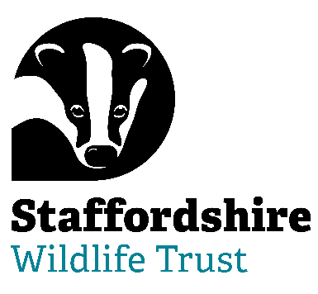

Staffordshire Wildlife Trust is seeking a:
Trustee and Honorary Secretary (Designate)
Volunteer Role
Help shape the future of our charity
Are you able to bring your skills and experience to help with Nature’s Recovery? Staffordshire Wildlife Trust, the leading local charity in Staffordshire, is dedicated to the conservation of nature and connecting people with their local wildlife.
We are seeking a committed and enthusiastic individual to join our Board as a Trustee and Honorary Secretary (Designate). This is an exciting opportunity to play a key role in supporting our charity’s governance and contributing to meaningful, long-term impact.
About the role
As a Trustee, you will share collective responsibility for ensuring the charity is well-run, financially sustainable and delivering on its charitable objectives. As Honorary Secretary (Designate), you will work alongside our current Secretary to gain a thorough understanding of the role before formally taking it on.
This is an ideal opportunity for someone looking to deepen their trustee experience or take on a pivotal governance position within a supportive and collaborative Board.
Key responsibilities
As a Trustee:
- Work with the Chair and the Board to advance and grow the reputation of Staffordshire Wildlife Trust as an organisation of excellence that can inspire collective leadership throughout its movement and beyond, in the wider world
- Ensure that the Trust pursues its charitable objects as defined in its Articles of Association. In summary these are:
  - For the benefit of the public, the conservation and protection of wildlife and its habitats, places of natural beauty or amenity value, and places of zoological, botanical, geographical, archaeological or scientific interest.
  - Educating the public in sustainable development and biodiversity conservation.
  - Promotion and undertaking of research in all areas of the natural world and publication of the results.
- Act in the best interests of the charity and its beneficiaries
- Contribute to strategic planning and decision-making
- Ensure the charity complies with its governing document and relevant legislation
- Actively participate in Board meetings and discussions
As Honorary Secretary (Designate):
- In conjunction with relevant staff ensure that the Trust and its subsidiaries comply with the requirements of company law, all relevant registers, such as the register of Members up to date and notifying Companies House of any changes in Directors/Trustees, prepare and filing the annual return and making sure that the Company documents are kept safely.
- to support the Chair of the Trust by ensuring the smooth functioning of the Board in conjunction with relevant staff
- to liaise with the other Trustees and Board members and lead them in discharging such functions as the Board may, from time to time, delegate to the Trustees.
- in conjunction with relevant staff to be responsible for:
  - ensuring the circulation of agendas, papers and minutes.
  - ensuring that a quorum is present at all meetings.
  - calling the Annual General Meeting and any Special or Extraordinary General meeting of the Company and ensuring that notices, agendas and minutes are duly served and that arrangements have been made for the holding of the meeting.
  - ensuring that minutes of all Board and General Meetings are kept and are signed by the Chair once approved.
  - receiving agenda items from other Trustees/staff;
  - acting on appraisal, recruitment and disciplinary panels as required.
Full handover and mentoring will be provided.
About you
We are looking for someone who:
- Has experience of HR and relevance of statutory legislation
- Has experience in charity and company law, and governance
- Is organised, reliable and detail-oriented
- Has good written communication skills
- Shares our values and commitment to our cause
- Is comfortable working collaboratively with others
Previous trustee experience is welcome but not essential. We particularly welcome applications from individuals who bring fresh perspectives and who are currently under-represented on charity boards.
Time commitment
Trustee Tenure: 4-year term with a maximum of 3 terms
Regularity: 9 meetings and per year + additional opportunities
Location: The Wolseley Centre, Wolseley Bridge, Stafford, ST17 0WT with occasional off-site meetings and visits
Why join us?
- Make a meaningful difference through your skills and experience
- Gain valuable governance and leadership experience
- Be part of a friendly, committed and supportive team
- Help shape the future direction of the charity
How to apply
To express your interest or request an application pack, please contact:
Staffordshire Wildlife Trust on jobs@staffs-wildlife.org.uk or visit our website Volunteering Opportunities | Staffordshire Wildlife Trust
Applications will be reviewed on a rolling basis.

Please refer to recruitment pack for key dates.

