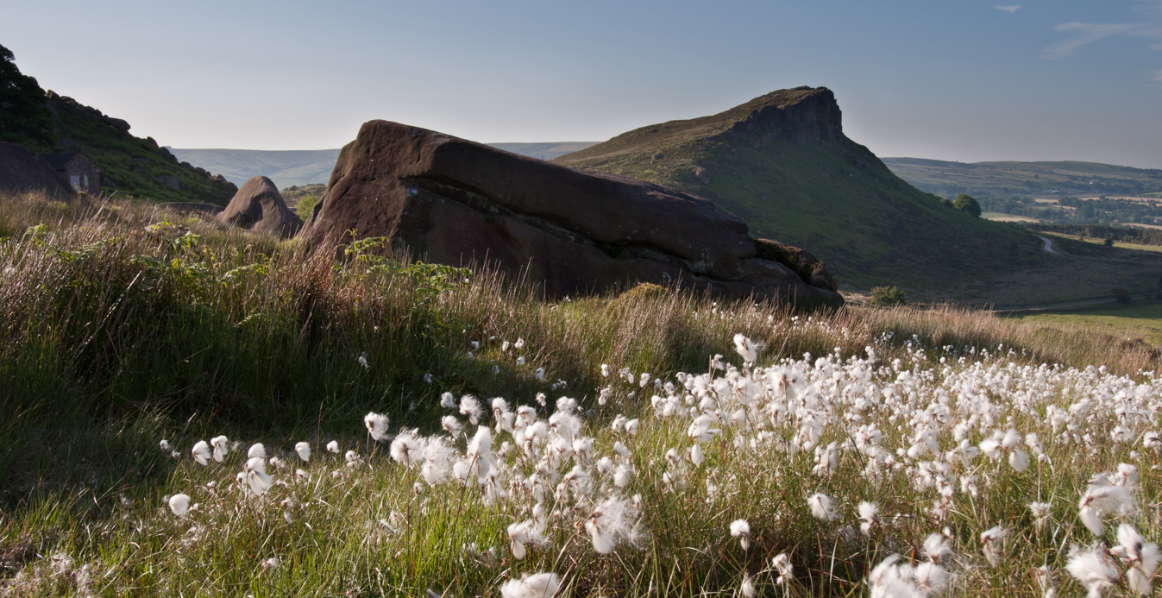
© Kevin Palmer
Weekend Sessional Rangers
Be part of a Wilder Future

Closing date: 9am Monday 30th March 2026
Interview date: Week commencing 30th March
To apply, please send no more than one sheet of A4, detailing why you are interested in the post and what skills and experience you can bring. Please send this to jobs@staffs-wildlife.org,uk
We will then be in touch to arrange an informal chat.

Our 50-year vision is for a thriving county with wildlife at its heart, which everyone enjoys, values and wants to play their part in protecting and improving.
Our mission is to ensure that:
We protect and enhance the wildlife and wild places of Staffordshire and promote understanding, enjoyment and involvement in the natural world.
Working for Staffordshire Wildlife Trust, in any role, means you are part of our ambition to halt and reverse natures decline in Staffordshire and across the UK, and to get more people to take meaningful action for wildlife. Whether you work in IT, in our cafes, or out on our nature reserves you will be working with colleagues towards the common purpose of a county richer in wildlife.

CHRISTINE HARDING SWT

Working for Us
At Staffordshire Wildlife Trust we don’t just offer jobs – we offer careers. For our people, being part of the effort to address the climate and nature crisis makes working for us truly meaningful and rewarding.
As well as investing in our mission, we invest in our people and culture. We’re committed to creating an engaging, supportive and inclusive workplace for all and providing opportunities for development, training and growth. We also provide a range of benefits such as flexible working, an employee assistance programme and a wellbeing allowance for contracted staff.
Your journey in the Trust starts with your induction. Whatever role you're here to do, we'll explain what to expect, show you where to go, and make sure you understand your new environment before you get going.
You’ll get chance to see what others in your teams, and across the Trust are doing through job shadowing and team working. We have 45 other Wildlife Trusts, working passionately just like us, whose knowledge and experience you can also draw from.
Learning and Development
One size doesn’t fit all, we will work with you to identify where you and the organisation want to grow and develop and put together a personal plan that works for you, whether that’s on-the-job training, flexible e-learning, or one-to-one support.

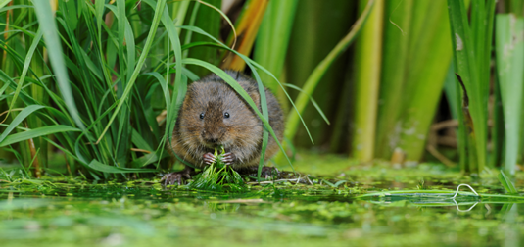
TERRY WHITTAKER 2020/VISION
What we stand for
We are:
Resourceful: Making best use of what we have, and always alive to opportunities to do things better and more efficiently
Passionate: Making the case for valuing and protecting wildlife
Pioneering: Using new and innovative ways to achieve our vision helping us led by example
Evidence Based: Making our case on scientific-face and interpretation
Welcoming: Giving our members, our supporters, and the wider public the best service possible
Professional: Striving to be the best we can be in all that we do, seeking continuous improvement and benchmarking our performance
Collaborative: Working in partnerships between staff, volunteers, members, communities, landowners, businesses and many others to achieve our vision
Safeguarding
Staffordshire Wildlife Trust is committed to keeping children and young people safe, you can see our policy here: https://www.staffs-wildlife.org.uk/our-policies
Safeguarding and protecting our visitors, customers, members, staff and volunteers is the responsibility of every trustee, employee, and volunteer at Staffordshire Wildlife Trust.

Our commitment to safeguarding starts at the very beginning. All recruiting managers complete Safer Recruitment training to enable them to follow best practice when recruiting.

On joining all staff are required to complete safeguarding training for children, young people and adults at risk.

Some roles require a successful DBS check before they can carry out their roles.
Our safeguarding team is committed to ensuring that our safeguarding policies and procedures are adhered to.

EDI – we’re wild about inclusion!
We aim to put equality, diversity and inclusion at the heart of Staffordshire Wildlife Trust to ensure that everyone can experience the joy of wildlife in their daily lives.

We’re Wild About Inclusion! To us, this means inspiring, empowering, and engaging people from all backgrounds, cultures, identities, and abilities, to change the natural world for the better. It means creating workspaces where difference is celebrated, everyone can be themselves and flourish, just like nature.

We aim to better understand and address the inequalities experienced by many communities in accessing and connecting with nature. This includes recognising that the conservation sector is one of the least diverse professions in the UK and that access to careers and educational opportunities needs to be significantly improved. We believe being Wild About Inclusion is critical to the future of the Trust, and the health and wellbeing of our communities.

The Basics
Job Title: Weekend Sessional Rangers
Contract Type: Sessional contract
Hours: Sessional hours to cover weekend afternoon / evenings and bank holidays until end Sept 2026.
Pay £18.02 per hour
Work Location: The Roaches, Leek, Staffordshire, ST13 8U
Who we’re looking for
During the wildfire season until the end September, the postholders will assist the Trust in patrolling the busy areas of the Roaches Nature Reserve during weekend afternoons, early evenings and Bank Holidays.

The main aspect of work is to look for any signs of smoke and fire on or near our landholding and reporting this as soon as possible to the emergency services and duty line manager. A further responsibility is to engage with visitors who may be planning to wild camp or have BBQs to prevent visitors lighting fires.

No detailed knowledge of wildlife of habitats is required but would be useful. We are looking for people happy to represent SWT and act in a friendly, welcoming and professional manner when engaging with visitors.
Logo clothing will be provided.

We hope to recruit enough sessional employees to cover all weekends and to have two people onsite at the same time but there may be some lone-working elements to the job
What you will deliver
- During the wildfire season (April to September) the postholder will work an agreed sessional rota of weekends and Bank Holidays as the Trust’s presence at the Roaches Estate. Working hours will coincide with the busiest times: mainly afternoons into the early evenings. The main tasks will be engaging with visitors at the main access points who could be preparing to BBQ or Wild Camp to prevent accidental fires.
- During the wildfire season the post holder will alert the emergency services should they spot signs of smoke or fire on SWT estate or the surrounding countryside and invoke the ‘Emergencies on Reserves’ response.
- The postholder, representing the Trust will take a friendly, welcoming and professional manner with visitors.
- At times there the post will involve working as part of the team to provide cover and support for other Reserves Staff.
- For the organisation to work effectively you may be required to assist with other areas of work and therefore you should be prepared to undertake other duties, appropriate to the post, as delegated by your line manager.
- All staff are required to abide by organisational policies and procedures.
- The post involves walking some distance walking over rough terrain.

What we’re looking for
Personal Qualities
Passionate and Energetic | You will be passionate about the countryside of the Peak District, especially the Roaches.
Team focused and supportive | Whilst there may be some lone working, We hope to recruit enough sessional workers to have two sessional workers working the same hours. We’re looking for at least 4 sessional workers in total.
Ambitious and Achieving | This role will require some evening and weekend working, as well as occasional unusual hours.
Professionalism | You will be a good advocate and represent the Trust at all times in a professional manner both with members of the public on site and professional partners.
Determination and Resilience | You will take pride in delivering high quality work while working in challenging conditions and in all weathers.
Problem Solving and Analysis | Often working in remote areas, you will be methodical in your approach to planning work and solving problems.

Qualifications
Full UK Driving Licence (preferably clean).
Essential requirements
Own vehicle is essential. A pool vehicle may be available for driving around the SWT Estate.
A broad knowledge and interest in natural history, especially upland habitats
You must be able to demonstrate the ability to organise your own workload and work unsupervised and as part of a small team.
The post will require various working patterns which include occasional early starts, evening finishes and weekend working.
The job involves working outside in all weather conditions and seasons.
The post requires strong communication skills with a variety of people including project staff, reserve visitors and members, partner organisations, land managers and landowners.
The job may involve manual handling and physical activities
Desirable requirements
Experience working in the environmental sector
Experience interacting with public and visitors
Knowledge of the Roaches Estate, the Southwest Peak and Staffs Moorlands.
Personal Qualities
Passion for the environment and wildlife conservation and engaging with a variety of audiences on these issues
A talent for thinking and working a in a flexible and creative way.
Sound judgement with a calm, confident, mature and pragmatic approach.

About us
“Staffordshire Wildlife Trust protects and enhances the wildlife and wild places of Staffordshire and promotes understanding, enjoyment and involvement in the natural world.”
A registered charity established in 1969, we are one of 46 county Wildlife Trusts throughout the UK and are supported by over 18,000 members.
The Trust owns or manages 45 nature reserves covering an area of over 1980 hectares. We have around 140 staff, based in six locations around the county including our Headquarters at Wolseley Bridge, Stafford, with our work divided into four departments: Conservation Delivery and Engagement, Fundraising and Development, HR & Support Services, and Resources. The Trust has a diverse workforce including site wardens, wildlife surveyors, community and education officers, catering, retail and administration.
In addition, we have a trading company which looks after the trading side of our business. This includes cafés at The Wolseley Centre, charity shops in Leek, Penkridge and Codsall and a retail shop in the Wolseley Centre.
We’re Wild About Inclusion! To us, this means inspiring, empowering and engaging people from all backgrounds, cultures, identities and abilities, to change the natural world for the better. It means creating workspaces where difference is celebrated, everyone can be themselves and flourish, just like nature
Staffordshire Wildlife Trust are committed to keeping children and young people safe, you can see our policy here: https://www.staffs-wildlife.org.uk/our-policies Safeguarding and protecting our visitors, customers, members, staff and volunteers is the responsibility of every trustee, employee, and volunteer at Staffordshire Wildlife Trust.
Disability Confident Employer: As a Disability Confident accredited employer, we guarantee to interview all disabled applicants who meet the minimum criteria for vacancies. We particularly encourage applications from people who are underrepresented within our sector, including people from minority backgrounds and people with disabilities. We are committed to creating a movement that recognises and truly values individual differences and identities.

At SWT, we are committed to creating a safe environment where discrimination, bullying, and harassment are not tolerated. We expect everyone to uphold, respect, and support our zero-tolerance policy.
For more information and to request an application pack contact Staffordshire Wildlife Trust on jobs@staffs-wildlife.org.uk or visit our website www.staffs-wildlife.org.uk/jobs
Staffordshire Wildlife Trust is a registered charity. Charity No: 259558.


