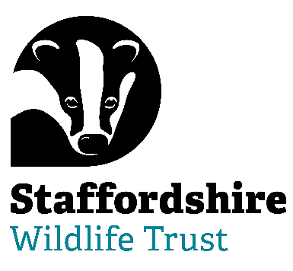**Staffordshire Wildlife Trading Ltd is seeking:**

***Non-Executive Director***

We are looking for a Non-Executive Director to join our Trading Board at an exciting time of growth and ambition.

A fully owned, yet independent company of The Staffordshire Wildlife Trust, the trading company manages and oversees the development of commercial enterprises for the Trust. This currently includes a café at The Wolseley Centre, charity shops in Leek, Penkridge and Codsall and a retail shop in the Wolseley Centre.

Whilst no previous experience of acting as a director is necessary, we are keen to talk to applicants with senior experience or knowledge in the Commercial / Retail / Business sectors.

The role of our directors is varied and stimulating and covers both overseeing operational activity within the trading company and contributing to the forward strategic development of the trading organisation. You will be bringing your expertise, experience and passion to help lead the company into the next phase of its development.

Director Tenure: 4 year term – maximum 3 terms

Regularity: Normally 4 Board Meetings per year at 1.30 pm on a Monday

Location: The Wolseley Centre, Wolseley Bridge, Stafford, ST17 0WT

**------------------------------------**

Staffordshire Wildlife Trust, the leading local charity in Staffordshire, is dedicated to the conservation of nature and connecting people with their local wildlife

*By contributing to the success of the trading company you will be helping us to protect and enhance the wildlife and wild places of Staffordshire and promote understanding, enjoyment and involvement in the natural world*

We are welcoming. One of the core values of Staffordshire Wildlife Trust is that we nurture a culture of equality, inclusivity and diversity.

We are welcoming to those underrepresented in our communities and we strive to listen, learn and share from each other.

Staffordshire Wildlife Trust is committed to keeping children and young people safe, you can see our policy here:  <https://www.staffs-wildlife.org.uk/our-policies>

Safeguarding and protecting our visitors, customers, members, staff and volunteers is the responsibility of every trustee, director, employee, and volunteer at Staffordshire Wildlife Trust and Staffordshire Trading Company.

For more information and to request an application pack contact Staffordshire Wildlife Trust on [jobs@staffs-wildlife.org.uk](mailto:jobs@staffs-wildlife.org.uk) or visit our website [Volunteering Opportunities | Staffordshire Wildlife Trust](https://www.staffs-wildlife.org.uk/volunteering-opportunities)

Should you wish to have an informal conversation regarding the opportunity please contact [jobs@staffs-wildlife.org.uk](mailto:jobs@staffs-wildlife.org.uk) advising of your contact details and we will respond as soon as possible.

**Closing Date**: **9am Monday 6th October 2025**

**Interviews: First interviews TBC**