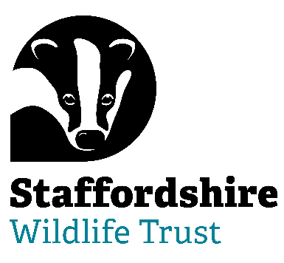

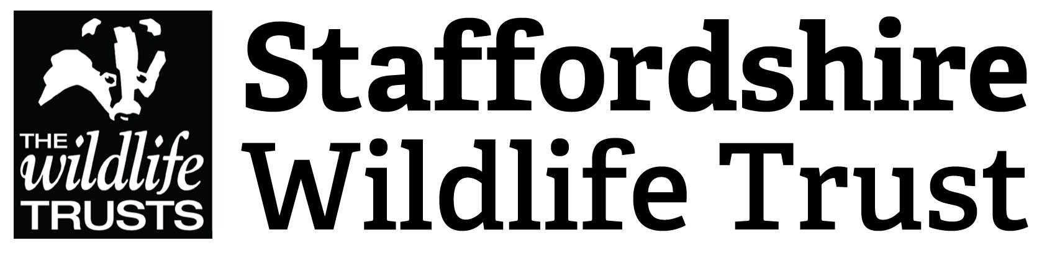
Role Description v2

Voluntary Trustee & Director of
Staffordshire Wildlife Trust

Background Information:
Our mission statement is:

“Staffordshire Wildlife Trust protects and enhances the wildlife and wild places of Staffordshire and promotes understanding, enjoyment and involvement in the natural world.”
A registered charity and company limited by guarantee established in 1969 we are one of 47 county Wildlife Trusts throughout the UK and are supported by over 15,000 members.
The Trust owns or manages 45 nature reserves covering an area of over 1947 hectares. Our circa 130 staff are based in six locations around the county including our Headquarters at Wolseley Bridge, Stafford, with our work divided up into five departments: Resources, People Engagement, Conservation Delivery, Fundraising, Communication and Membership & Commercial. The Trust has a diverse workforce of including site wardens, wildlife surveyors, community and education officers, catering, retail and administration.

In addition, we have a trading company which looks after the trading side of our business. This includes cafés at The Wolseley Centre, charity shops in Leek, Penkridge and Codsall and a retail shop in The Wolseley Centre.

We are welcoming. One of the core values of Staffordshire Wildlife Trust is that we nurture a culture of equality, inclusivity and diversity. We are welcoming to those underrepresented in our communities and we strive to listen, learn and share from each other.

Staffordshire Wildlife Trust are committed to keeping children and young people safe, you can see our policy here: https://www.staffs-wildlife.org.uk/our-policies
Safeguarding and protecting our visitors, customers, members, staff and volunteers is the responsibility of every trustee, employee, and volunteer at Staffordshire Wildlife Trust.

We expect the Chair and Trustees to uphold this commitment and we require Disclosure and Barring Service checks to be carried out where appropriate.

Job Purpose:
We’re at an exciting time in our organisation’s development. We have some big ambitions and transformations that we need to deliver to achieve our new strategy and secure nature’s recovery.
This is not least around how we can become a more inclusive organisation and reach out and support more people from all backgrounds to experience nature but also how we can become an even stronger federation in the ways we work together and capitalise on our structures. We therefore need a forward thinking and inclusive Trustee to join the Board and help lead us on our journey.
The Trustee will be able to combine personal humility with an urgency to achieve the mission of Staffordshire Wildlife Trust and the drive to invest in ongoing organisational development. They will be able to demonstrate leadership and be able to unite and inspire our movement behind our collective vision.
Embodying the culture of The Wildlife Trusts, the Trustee will work with the Chair and the Board to advance and grow the reputation of Staffordshire Wildlife Trust as an organisation of excellence that can inspire collective leadership throughout its movement and beyond, in the wider world.
This can be a demanding, yet rewarding role, suited to someone who is able to navigate through complex relationships and communicate well at all levels. Being able to motivate and bring people on a journey is a must.
This is a voluntary position, it is not remunerated although expenses may be reimbursed.
All Trustees are also Directors of Staffordshire Wildlife Trust Ltd.

Responsibilities:

The duties of a Trustee are:

- to ensure that the Trust pursues its charitable objects as defined in its Articles of Association. In summary these are:
  - For the benefit of the public, the conservation and protection of wildlife and its habitats, places of natural beauty or amenity value, and places of zoological, botanical, geographical, archaeological or scientific interest;
  - Education of the public in sustainable development and biodiversity conservation;
  - Promotion and undertaking of research in all areas of the natural world, and publication of the results.

- to ensure that the Trust applies its resources exclusively in pursuance of those objects and in particular to ensure that money is not spent on activities which are not included in the objects, no matter how worthwhile or charitable those activities may be.

- to contribute actively to the role of the Board of the Trust in giving firm strategic direction to the Trust, in particular setting overall policy and defining goals and, through the Chief Executive, setting targets and evaluating performance against targets.

- to ensure the financial stability of the Trust.

- to protect and manage the property of the Trust and to ensure the proper investment of the Trust's funds.

- to safeguard the good name and values of the Trust.

- to ensure the effective and efficient administration of the Trust by the appointment of, as appropriate, a Chief Executive and other members of staff.

- to ensure that the Trust complies with its Memorandum and Articles of Association, charity law, company law and any other relevant legislation or regulations.

- to promote and support inclusive leadership throughout The Board as part of the SWT Equality Diversity & Inclusion strategy.

- To be aware of their safeguarding responsibilities and take responsibility for promoting and safeguarding people and ensure that this is a priority for the charity.

- in addition to the foregoing, which are the statutory duties of Trustees, each Trustee should use his or her own knowledge or experience, whether in matters of nature conservation, education, finance, law, industry, business etc,, to help the Board of the Trust reach sound decisions. In particular, this will involve:

- a willingness to devote the necessary time and effort to the business of the Trust
- exercising good independent judgement
- an ability to work effectively as a member of a team
- scrutinising Board papers and preparing adequately for Board meetings
- leading discussions where appropriate and participating fully in all discussions
- focussing on key issues
- providing advice and guidance requested by the Board in areas of the Trust's work in which the Trustee has special expertise

Person Specification :
The skills and experiences we are looking for are :

- Education/children sector, including safeguarding
- Leading, motivating and empowering others
- Building trusting relationships
- Developing strategy
- Effecting change
- Flexibility, sensitivity and consensus building
- Innovation and creativity
- Leading with a visionary and strategic perspective
- Networking, influencing and negotiating with a wide range of stakeholders
- Partnership working
- Conflict resolution
- Rational, clear thinker who forms judgements independently
- A natural team player and good listener
- Adept and persuasive communicator, confident on a stage
- Some understanding of relevant legal duties, responsibilities and liabilities (although training will be given)
- Business acumen
- Performance management
- Finance management

