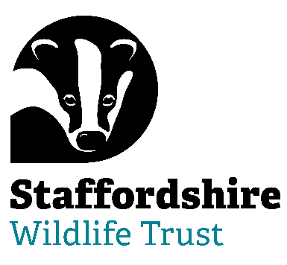**Staffordshire Wildlife Trust is seeking a:**

***Voluntary Trustee***

**Are you able to bring your skills and experience to help with Nature’s Recovery? Staffordshire Wildlife Trust, the leading local charity in Staffordshire, is dedicated to the conservation of nature and connecting people with their local wildlife**

Trustee Tenure: 4-year term – maximum 3 terms

Regularity: 9 meetings a year + additional opportunities

Location: The Wolseley Centre, Wolseley Bridge, Stafford, ST17 0WT

**We are seeking a forward thinking and inclusive Trustee, especially someone with experience or knowledge in the education/children sector (including safeguarding), to join the Board and help lead us on our journey.**

This is not least around how we can become a more inclusive organisation and reach out and support more people from all backgrounds to experience nature but also how we can become an even stronger federation in the ways we work together and capitalise on our structures.

The Trustee will be able to combine personal humility with an urgency to achieve the mission of Staffordshire Wildlife Trust and the drive to invest in ongoing organisational development.  They will be able to demonstrate leadership and be able to unite and inspire our movement behind our collective vision.

Embodying the culture of The Wildlife Trusts, the Trustee will work with the Chair and the Board to advance and grow the reputation of Staffordshire Wildlife Trust as an organisation of excellence that can inspire collective leadership throughout its movement and beyond, in the wider world.

This can be a demanding, yet rewarding role, suited to someone who is able to navigate through complex relationships and communicate well at all levels. Being able to motivate and bring people on a journey is a must.

No previous experience of acting as a Trustee is necessary.

***Help us to protect and enhance the wildlife and wild places of Staffordshire and promote understanding, enjoyment and involvement in the natural world.***

The role of our Trustees is varied and stimulating. You will be bringing your expertise, experience and passion to help lead a dynamic, multi-functional, multi-specialist organisation.

**About Us**

“Staffordshire Wildlife Trust protects and enhances the wildlife and wild places of Staffordshire and promotes understanding, enjoyment and involvement in the natural world.”

A registered charity established in 1969, it is one of 46 county Wildlife Trusts throughout the UK and is supported by over 19,000 members.

The Trust owns or manages 45 nature reserves covering an area of over 1947 hectares. Our circa 130 staff are based in six locations around the county including our Headquarters at Wolseley Bridge, Stafford, with our work divided up into five departments: Conservation Delivery, Engagement, Marketing & Activism, Fundraising, Membership & Resources, HR & Support Services and Commercial. The Trust has a diverse workforce including site wardens, wildlife surveyors, community and education officers, catering, retail and administration.

In addition, we have a trading company which looks after the trading side of our business. This includes a café at The Wolseley Centre, charity shops in Leek, Penkridge and Codsall and a retail shop in the Wolseley Centre.

We are welcoming. One of the core values of Staffordshire Wildlife Trust is that we nurture a culture of equality, inclusivity and diversity.

We are welcoming to those underrepresented in our communities and we strive to listen, learn and share from each other.

Staffordshire Wildlife Trust is committed to keeping children and young people safe, you can see our policy here:  <https://www.staffs-wildlife.org.uk/our-policies>

Safeguarding and protecting our visitors, customers, members, staff and volunteers is the responsibility of every trustee, employee, and volunteer at Staffordshire Wildlife Trust.

For more information and to request an application pack contact Staffordshire Wildlife Trust on [jobs@staffs-wildlife.org.uk](mailto:jobs@staffs-wildlife.org.uk) or visit our website [Volunteering Opportunities | Staffordshire Wildlife Trust](https://www.staffs-wildlife.org.uk/volunteering-opportunities)

**Closing Date**: Monday 15th September 2025

**First Interviews:** week commencing Monday 22nd September 2025