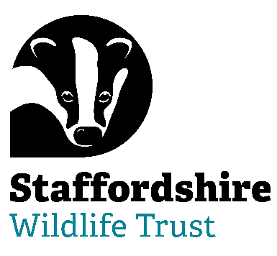

**Staffordshire Wildlife Trust is seeking a :**

**Trustee/Honorary Treasurer Designate**

**Trustee Tenure:** **4-year term – maximum 3 terms**

**Regularity:**  **9 meetings a year + additional opportunities**

**Location:**  **The Wolseley Centre, Wolseley Bridge, Stafford, ST17 0WT**

**Are you able to bring your skills and experience to help with Nature’s Recovery? Staffordshire Wildlife Trust, the leading local charity in Staffordshire, is dedicated to the conservation of nature and connecting people with their local wildlife**

**We are looking for a forward-thinking and inclusive Trustee to work towards serving as the Board’s Treasurer.**

The Treasurer should be a qualified accountant (ICAEW,CIPFA,ACCA,ICMA) and have previous experience in business and commercial roles in order to take the lead on the Board for financial issues from June 2027; ensuring that SWT’s financial accounts are accurate, timely, comply to best accountancy practice and reflect SWT’s true financial position.

This can be a demanding, yet rewarding role, suited to someone who is able to navigate through complex relationships and communicate well at all levels. Being able to motivate and bring people on a journey is a must.

The Treasurer also has responsibilities of trusteeship/directorship.

***Help us to protect and enhance the wildlife and wild places of Staffordshire and promote understanding, enjoyment and involvement in the natural world.***

The role of our Trustees is varied and stimulating. You will be bringing your expertise, experience and passion to help lead a dynamic, multi-functional, multi-specialist organisation.

**About Us**

“Staffordshire Wildlife Trust protects and enhances the wildlife and wild places of Staffordshire and promotes understanding, enjoyment and involvement in the natural world.”

A registered charity established in 1969 it is one of 46 county Wildlife Trusts throughout the UK and is supported by over 19,000 members.

The Trust owns or manages 45 nature reserves covering an area of over 1947 hectares. Our circa 130 staff are based in six locations around the county including our Headquarters at Wolseley Bridge, Stafford, with our work divided up into five departments: Conservation Delivery, Engagement, Marketing & Activism, Fundraising, Membership & Resources, HR & Support Services and Commercial. The Trust has a diverse workforce including site wardens, wildlife surveyors, community and education officers, catering, retail and administration.

In addition, we have a trading company which looks after the trading side of our business. This includes a café at The Wolseley Centre, charity shops in Leek, Penkridge and Codsall and a retail shop in the Wolseley Centre.

We are welcoming. One of the core values of Staffordshire Wildlife Trust is that we nurture a culture of equality, inclusivity and diversity.

We are welcoming to those underrepresented in our communities and we strive to listen, learn and share from each other.

Staffordshire Wildlife Trust is committed to keeping children and young people safe, you can see our policy here:  <https://www.staffs-wildlife.org.uk/our-policies>

Safeguarding and protecting our visitors, customers, members, staff and volunteers is the responsibility of every trustee, employee, and volunteer at Staffordshire Wildlife Trust.

For more information and to request an application pack contact Staffordshire Wildlife Trust on [jobs@staffs-wildlife.org.uk](mailto:jobs@staffs-wildlife.org.uk) or visit our website [Volunteering Opportunities | Staffordshire Wildlife Trust](https://www.staffs-wildlife.org.uk/volunteering-opportunities)

**Closing Date**: Monday 15th September 2025

**First interview Date:** Week commencing Monday 22nd September 2025