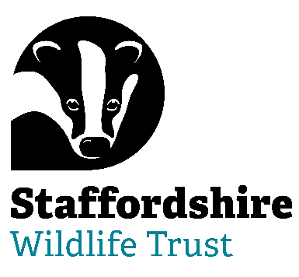**Staffordshire Wildlife Trust is seeking a:**

***Trustee/Honorary Secretary Designate***

**Are you able to bring your skills and experience to help with Nature’s Recovery? Staffordshire Wildlife Trust, the leading local charity in Staffordshire, is dedicated to the conservation of nature and connecting people with their local wildlife**

Trustee Tenure: 4-year term – maximum 3 terms

Regularity: 9 meetings a year + additional opportunities

Location: The Wolseley Centre, Wolseley Bridge, Stafford, ST17 0WT

**We are seeking a forward-thinking and inclusive Trustee to join the Board and work towards assuming the role of the Board’s Honorary Secretary and help lead us on our journey.**

The Honorary Secretary will be able to combine personal humility with an urgency to achieve the mission of Staffordshire Wildlife Trust and the drive to invest in ongoing organisational development.  They will be able to demonstrate servant leadership and be able to unite and inspire our movement behind our collective vision.

Embodying the culture of The Wildlife Trusts, the Honorary Secretary will work with the Chair and the Board to advance and grow the reputation of Staffordshire Wildlife Trust as an organisation of excellence that can inspire collective leadership throughout its movement and beyond, in the wider world.

This can be a demanding, yet rewarding role, suited to someone who is able to navigate through complex relationships and communicate well at all levels. Being able to motivate and bring people on a journey is a must.

This is a role that is elected to annually by the Board of trustees.

The role of our Trustees is varied and stimulating. You will be bringing your expertise, experience and passion to help lead a dynamic, multi-functional, multi-specialist organisation.

***Help us to protect and enhance the wildlife and wild places of Staffordshire and promote understanding, enjoyment and involvement in the natural world.***

**About Us**

“Staffordshire Wildlife Trust protects and enhances the wildlife and wild places of Staffordshire and promotes understanding, enjoyment and involvement in the natural world.”

A registered charity established in 1969 and is one of 46 county Wildlife Trusts throughout the UK and is supported by over 19,000 members.

The Trust owns or manages 45 nature reserves covering an area of over 1947 hectares. Our circa130 staff are based in six locations around the county including our Headquarters at Wolseley Bridge, Stafford, with our work divided up into five departments: Conservation Delivery, Engagement, Marketing & Activism, Fundraising, Membership & Resources, HR & Support Services and Commercial. The Trust has a diverse workforce including site wardens, wildlife surveyors, community and education officers, catering, retail and administration.

In addition, we have a trading company which looks after the trading side of our business. This includes a café at The Wolseley Centre, charity shops in Leek, Penkridge and Codsall and a retail shop in the Wolseley Centre.

We are welcoming. One of the core values of Staffordshire Wildlife Trust is that we nurture a culture of equality, inclusivity and diversity.

We are welcoming to those underrepresented in our communities and we strive to listen, learn and share from each other.

Staffordshire Wildlife Trust is committed to keeping children and young people safe, you can see our policy here:  <https://www.staffs-wildlife.org.uk/our-policies>

Safeguarding and protecting our visitors, customers, members, staff and volunteers is the responsibility of every trustee, employee, and volunteer at Staffordshire Wildlife Trust.

For more information and to request an application pack contact Staffordshire Wildlife Trust on [jobs@staffs-wildlife.org.uk](mailto:jobs@staffs-wildlife.org.uk) or visit our website [Volunteering Opportunities | Staffordshire Wildlife Trust](https://www.staffs-wildlife.org.uk/volunteering-opportunities)

**Closing Date**: Monday 15th September 2025

**First Interview Date:** Week commencing Monday 22nd September 2025