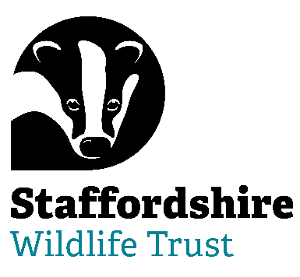
Staffordshire Wildlife Trust are seeking

Voluntary Trustees

Are you able to bring your skills and experience to help with Nature’s Recovery? Staffordshire Wildlife Trust is the leading local charity dedicated to the conservation of nature and connecting people with their local wildlife

Trustee Tenure : 4 year term – maximum 3 terms

Regularity : 9 meetings a year + additional opportunities

Location: The Wolseley Centre, Wolseley Bridge, Stafford, ST17 0WT

Help us to protect and enhance the wildlife and wild places of Staffordshire and promote understanding, enjoyment and involvement in the natural world.

We are looking for Trustees to join our Board at an exciting time of growth and ambition. Join us on our journey to reach 30% of land managed for wildlife by 2030 and 1 in 4 people taking action for wildlife in Staffordshire.

No previous experience of acting as a Trustee is necessary. We are especially looking for applicants with experience or knowledge in the following areas:

- Charity Sector Finance and/or Fundraising
- IT & Digital expertise
- Education/children sector, including safeguarding
- Environment and Ecology

The role of our Trustees is varied and stimulating. You will be bringing your expertise, experience and passions to help lead a dynamic, multi-functional, multi specialist organisation.
For more information and to request an application pack contact Staffordshire Wildlife Trust on jobs@staffs-wildlife.org.uk or visit our website www.staffs-wildlife.org.uk/jobs

Closing Date: Friday 5th April 2024
Interviews: Week commencing 29th April 2024

