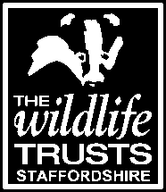

Staffordshire Wildlife Trust is seeking :

Casual Catering Assistants (Westport Lake)

National Minimum Wage
Zero Hour Contract

Weekend working standard plus school holidays
(would suit college/university students but must be over 16 years of age)

We are looking for people with friendly, professional personalities to support the Supervisor in the day-to-day food & beverage operations at Westport Lake Cafe & Visitor Centre.

You will help to ensure the facilities are accessible to all users and high standards are adhered to throughout. This is a busy cafe so you will need to work well under pressure, be flexible and work as part of team to provide excellent customer service at all times.

We are looking for people with :

- Some previous experience within a food & beverage retail outlet, including till work is desirable, but full training will be given
- Effective communication skills
- Good numeracy and literacy skills
- Good organisational skills

Application forms are available from Westport Lake Visitor Centre or by downloading an application pack from our website.

