
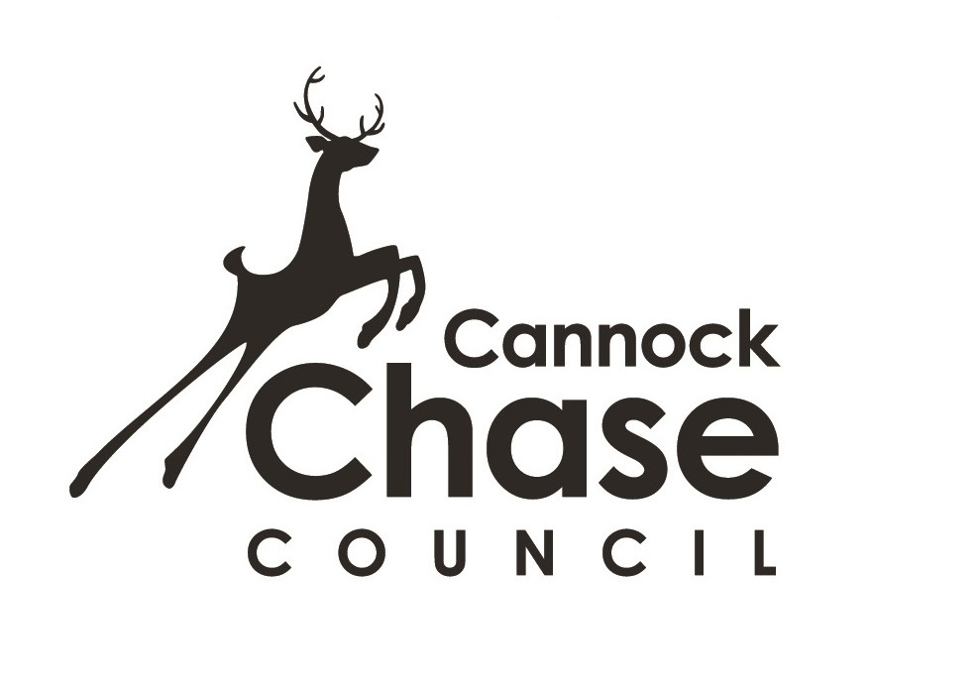
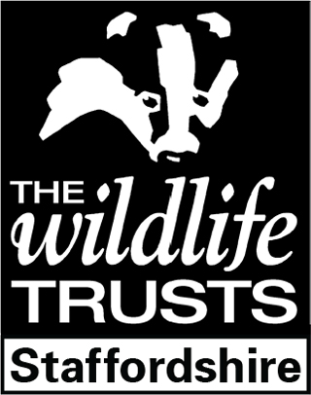
Wild About Staffordshire 2019 Entry Form

We are inviting artists and photographers to submit artworks for our exhibition ‘Wild About Staffordshire – Celebrating 50 Years of Staffordshire Wildlife Trust.’
Artworks must be inspired by the landscapes, flora and fauna of Staffordshire. Artists are encouraged to visit some of the Staffordshire Wildlife Trust reserves, be inspired and capture what is beautiful about these special places in their finished pieces.

Dates to submit (no more than 2 pieces): Thurs 17th, Fri 18th October (11am - 4pm)
Sat 19th (11am – 1pm), Mon 21st (10am-12noon)
Date of notification: Tues 22nd October
Collection Date if unsuccessful: Wed 23rd to Fri 25th October (11am - 4pm)
Collection Date if successful: Wed 18th & Thurs 19th Dec (11am - 4pm)
Exhibition on show at the museum: Monday 28th October to Tuesday 17th December

NAME

ADDRESS

TELEPHONE | E MAIL  (We are most likely to contact you by email)
1 - DESCRIPTION AND TITLE  OF WORK ENTERED |  |  | For Sale?  Yes/No | Price inc. 15% commission fee  £
Please briefly explain the subject, meaning and ethos behind your submitted piece. How does it fit the criteria?
Would you be willing to donate a percentage of any sales in this exhibition to the Staffordshire Wildlife Trust (excluding commission)? | Yes | No | Percentage %

To be completed by Museum Staff in front of person delivering work. | Please check artwork and agree with deliverer any existing damages, then record it below. Do not give the receipt until this has been done.

- Please read conditions and criteria overleaf. Items that do not comply will be rejected. Please note that the organisers reserve the right to reject any works without explanation.
- Bring this completed form with you, on your chosen delivery date, above, with your work. Please note that we can only accept works on the dates for submission given above.
- Please ensure that your artwork is framed and has picture plates attached ready for mounting. Artworks not meeting these conditions will be rejected.

I have read and understood and agree to abide by the Entry Form, Conditions and Criteria.

Signed by the artist: ____________________________Date: ___________________________

Wild About Staffordshire Conditions and Criteria

Applicants’ work must be presented professionally and have a clear link to the entry criteria.
All work must be clearly and securely labelled with your name and the title of the piece, for identification. Please place on the reverse of images and underneath of objects, so that they are not visible during exhibition. Works not clearly labelled will be excluded from selection.

All 2-d images must be delivered ready to hang with flat picture plates. Screw eye fixtures will not be accepted, as they are not secure for public display. 2-d works without flat picture plates will be automatically excluded from selection. Please ensure that picture plates are attached so that appropriate screws can easily be used.
All 3-d objects must be robust, stable and if appropriate be supplied with stands for support. If not, we can’t accept responsibility for any damage that may occur.

The museum’s insurance policy will provide blanket cover for items whilst on display. No responsibility will be accepted during transit.

Items must not be removed from the exhibition before it has finished. Exhibitors will not have access to on-site administration facilities / office accommodation.

Should you choose to sell your work, we will handle the administration of the sale. Please note that all sales are subject to a 15% commission fee payable to the museum by the artist.

No responsibility can be taken by the museum for the delivery of any items sold to the purchaser. If any sold items remain uncollected 1 week after the exhibition ends, exhibitors must undertake the removal of the items, and make private arrangements with the purchaser.

The museum reserves the right to display and exclude works as it deems necessary, without explanation. The museum reserves the right to close the gallery at any time throughout the exhibition.

Successful applicants’ work may be photographed and appear in promotions and publicity material, to promote the event. Unsuccessful applicants will be informed on the date overleaf. Please note the dates of collection.

If you wish, please supply ONE A4 sheet with details of your work and practice. This will be available to visitors during the exhibition. For example: How long have you been developing your skills? Are you a member of a local group? Do you undertake commissions?

Data Protection – we will not pass on your details to anyone outside Inspiring Healthy Lifestyles, Staffordshire Wildlife Trust or Cannock Chase Council. We will only use your details in relation to your entry to the Wild About Staffordshire exhibition. Please contact us if you wish us to delete your details.

Selection process
- The aim of the Wild About Staffordshire exhibition is to celebrate 50 Years of Staffordshire Wildlife Trust and to inspire artists to visit its reserves and capture the unique beauty of their landscapes, flora and fauna. The aim of the Staffordshire Wildlife Trust is to protect and enhance the wildlife and wild places of Staffordshire & to promote understanding, enjoyment and involvement in the natural world.
- Work will be selected to represent a broad range of creative skills and media. It will take into account how the artist has responded to the theme. All types of visual art are welcomed including painting, drawing, photography, textiles and 3D works.
- The exhibition is FREE to enter, and will be advertised locally and in the museum’s diary of events, Inspiring Healthy Lifestyles marketing materials, Facebook and the museum website and by the Staffordshire Wildlife Trust.
- Think creatively about the theme, it doesn’t have to be the obvious! But please explain how you have met the criteria on the form as this will assist us with the selection process.
Queries? Contact the Museum of Cannock Chase on 01543 877666

