Thanks for joining our campaign!

We are excited you want to be part of our nature audio journal for children.

Below are some ideas and tips to help you create;

Once Upon A Time, I Saw..... an audio journal of children’s experiences of nature during lock down.
- Voice only recordings. No video please.
- Try and do your recording somewhere quiet and still
- Up to 1 minute of audio. If you have more send it but it may not all be used.
- Children aged 6-12 to submit only please
- Always start with the sentence “Once Upon A Time, I Saw.... ”
- Deadline 10th July 2020
- Email to send files – wildchildfestival@staffs-wildlife.org.uk
- The free version of Wetransfer.com is an excellent way to send large files

What we are looking for are voice only recordings, that showcase your children’s creativity and the small and large bits of nature they see during lockdown. We will select the best ones and create an audio journal.

We feel it is important to show how much nature has helped us all during this time and to help teach our children to look for the awe inspiring, calming nature around them when they cannot come access spaces such as the Staffordshire Wildlife Trust sites.

Tips to spark the children’s creativity:

- Take your children on an adventure outside, to the garden, the street or the park. Ask the children to tell you the nature they see, find 5 things in the soil, on a path, in the air, anywhere. Describe colours, sounds, touch. How does it make them feel? What do they like about it? Then head home, pick one, write it down together, if you wish, then simply record them speaking into your phone and send to us, at the Wildlife Trust. Make sure they start the recording with the sentence “Once Upon A Time, I Saw....”.

How do I record?

- Record your story as an audio only file using the voice memo or voice record feature on your mobile phone or use an alternative recording device. Please DO NOT use what’s app to record as it compresses the sound files.
- By sending the files, you are giving us permission to edit and creatively use on the project “Once Upon A Time, I Saw” only.
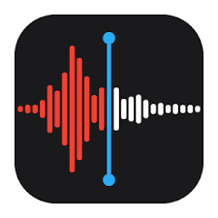
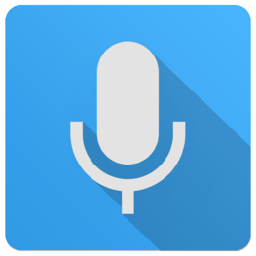
- Icons for voice recorder or voice memo on Android or iPhone ( shown in this order).

- 1 min. tutorial to find your voice recorder on iPhone if you cannot find it.
https://www.youtube.com/watch?v=oVSSdI-I7y4

